MultiTroniks LVX Troubleshooting

Laser Analysis Problems

A distinguishing characteristic of a laser problem is after picking and moving a component over the placement point the theta axis does a series of turns and then the part is put back. The laser is not seeing the part. This is most likely caused by the part’s scan depth not being set up correctly. The scan depth should be set according to the type of package as follows:
For a chip type component the scan depth should be set to approximately 50% of its height as shown in figure 1.

Scan a chip type component at 50% of its height.

Figure 1

For an package with leads the scan depth should be set to scan the vertical part of the lead as shown in figure 2.
Don’t scan here. Package shape will adversely affect placement.
Scan a leaded type component on the vertical part of the leads.

Figure 2

Odd shaped parts should be scanned where the outline of the part best describes the shape of the part. Avoid scanning a thin edge on a large part. Try to scan at the point with the greatest substance. See figure 3. For some unusual parts a little trial and error may be necessary to find a suitable scan depth.

Scan the point that best describes the outline of the package.
Do not scan a chamfered edge.
Avoid scanning a thin edge of a large part. Also do not scan a non-symmetrical groove.

Figure 3

Melfs and melf nozzles present a special situation and require a slightly different package settings. First, since the melf itself sits partly inside the nozzle as opposed to on the tip of the nozzle, the package height should be roughly half the melfs diameter (see figure 4). An accurate measurement of the height can be attained by measuring the overall length of the nozzle and then measure the length of the nozzle with the part on the tip in its picking position. The difference of these two measurements is the working package height. The melf should then be scanned approximately five thousandths (.005) below the nozzle tip (see figure 4).

‘Working Height’ of melf is about one half of package diameter.
For best results, scan just below nozzle edge.

Figure 4
If you are confident that the scan height is set correctly and the part still cannot be placed then there are two other possible problems. First, the nozzle scan height may not be set properly (this may be especially true if you’ve changed to a new nozzle or have severely damaged a nozzle tip). To correct this, inspect the problem nozzle (replace if bad) and/or run the laser calibration on that nozzle.
The second reason may be a problem with the laser itself. Clean the laser as described in the maintenance manual and then reboot the machine. If the problem persists then contact a Multitroniks service person.

Fine Pitch Camera Analysis Problems

If you are having trouble with the fine pitch camera analysis you should review the section on teaching a part in the programming manual. In addition to this there are a few things you can do to help discover the problem.
Go into the vision processor screen. With the mouse over the black picture window click the right mouse button. A menu will be displayed with Open, Save, Save As, Debug Off, and Debug On options. Choose Debug On. This enables a feature that automatically stores the last good part and the last bad part in a gray scale file format. After you run an assembly a picture will be saved under the name ‘lastgood’ if the part passed inspection or under ‘lastbad’ if the part failed inspection.
If there is a part that analyzes as bad for no known reason you can look at it with the vision processor. This is done by starting the Package Editor, selecting the package you are analyzing, and then selecting Vision Processor from the menu line option Function. With the mouse pointer positioned over the black picture window, click the right mouse button. Select open and choose the file ‘LastBad.raw’. The problem part will be displayed and at this point you can analyze it using Memory Analyze and Test Mode Analyze. Change threshold and minimum area settings as needed but be aware that these new values will save unless you return them to their initial value before exiting.
After pressing Test Mode Analyze look closely at the green grid lines and green circles drawn. The green grid is derived from the length and width of the part. If the part is outside of this green grid check the package parameters and orientation of the part in the feeder.
The green circles represent where the machine has ‘found’ a lead. Count the green circles to see if this matches what is in the leads definition editor – maybe you have the wrong package for this part. Or maybe some of the leads are bent together and appear as one. Also check the leads pitch setting. An error with pitch will cause what appears to be a perfectly good part to fail because the leads are not where they should be.

Picking Problems

There are several major functions of the machine that will affect part picking. They are as follows:

X,Y,Z pick up point. Confirm that the X,Y coordinate and the Z coordinate are programmed properly.

Feeder. Check to make sure the feeder is in working order. If this is a tape feeder, check the pitch number and compare to the pitch of the tape.

Package Parameters. A larger pick delay may be necessary so that the vacuum has enough time to grab a heavy part. Head speed may also be decreased to help picking.

Nozzles. If there are two nozzles that might fit the part try both to see if one works better. Make sure the nozzle you use is in good condition.

Vacuum Sensor. (Note: This section only applies to machines with the old style vacuum system. If the vacuum turns on for a brief moment each time a nozzle is picked up the machine is equipped with the new system. In this case, the sensor automatically sets up and no adjustment is necessary.) A part that is picked up and then dropped usually signifies an incorrect adjustment of the vacuum sensor. To check the vacuum sensor have the head pick up a nozzle (use a small nozzle like #1 or #2). Using the jog panel move the head to the back of the machine. Select Test Functions from the menu and then select the I/O Test option. The menu shown in figure 5 will be shown. Click on the Vacuum button. This will turn the vacuum on.

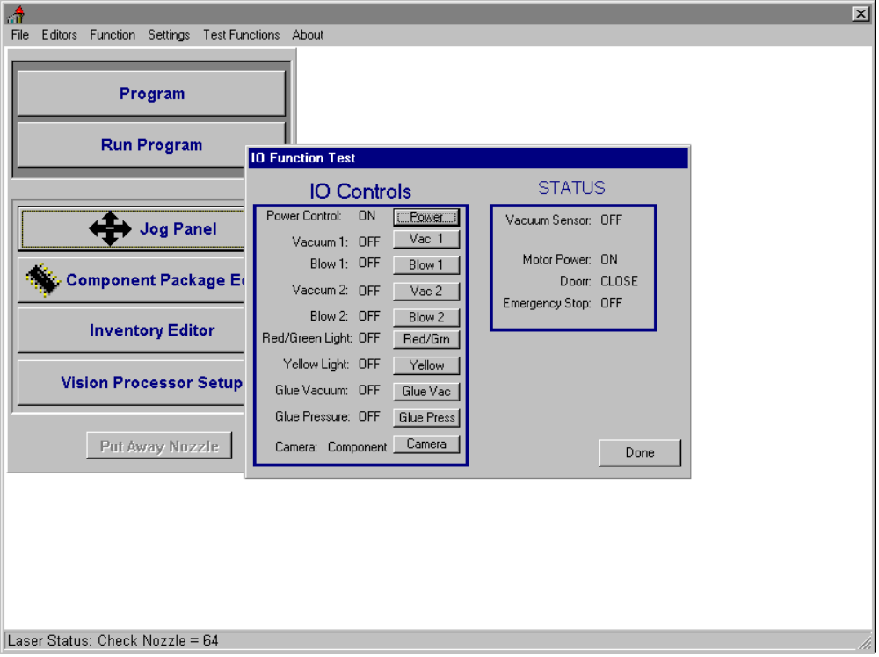
Figure 5

Go to the back of the machine and open the door. The vacuum sensor can be seen through the opening in the head cover. See figure 6. Touch the bottom of the nozzle with your finger to block the vacuum(try using your thumbnail, though it is difficult to get the correct angle, it is a better representation of a part than the fleshy part of your finger). The vacuum sensor LED should light signifying that the sensor has switched (you should also see the change occur on the I/O Test menu in software). Using a smallish straight blade screw driver turn the adjustment screw counter clockwise to make it less sensitive or clockwise to make it more sensitive. The sensor should react reasonably fast to the tap of a finger against the nozzle tip.
Once you are satisfied with the switch performance close the rear door and turn the vacuum off by clicking the Vacuum button again. Close the I/O Test menu and retest your part. If the problem persists you may need to make the sensor slightly more sensitive.

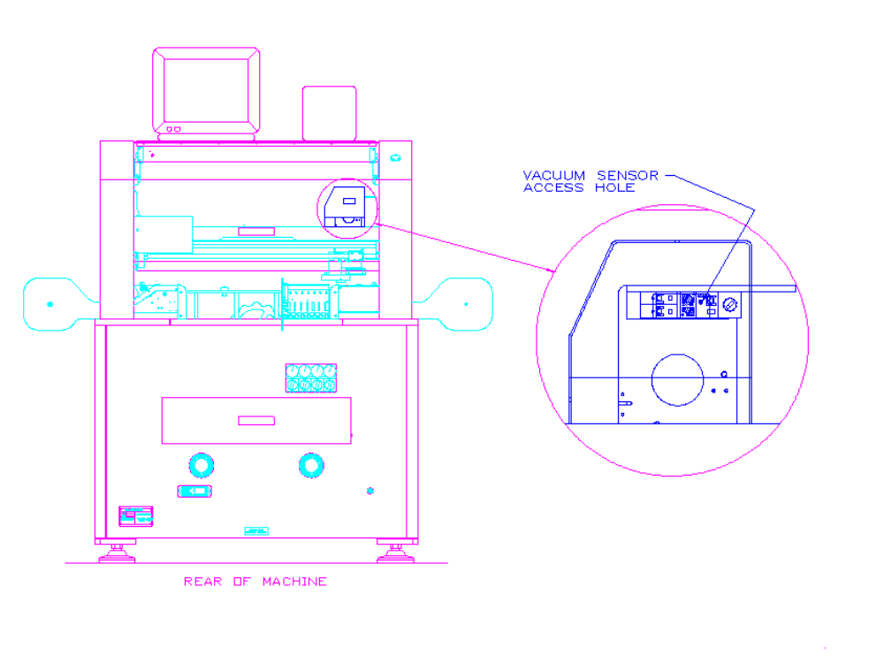

Figure 6

Placement Problems

There are several major functions of the machine that will affect placement. They are as follows:

Calibration of the machine. Poor machine calibration will effect all parts being placed though it may be more noticeable on some parts like fine pitch qfps. If you suspect poor machine calibration see the Calibration section in the Installation and Maintenance Manual.

Component analysis. See the above section on troubleshooting laser and fine pitch camera analysis.

Nozzles. If there are two nozzles that might fit the part try both to see if one works better. Make sure any nozzle you use is in good condition.

Package measurement parameters. Check all measurement parameters against the actual part. Although the settings in the package library were based on industry standards (if there is such a thing), packages from different manufacturers will vary - sometimes critically. Double check the package height because this will determine if the part is pushed down onto the board causing a shift or dropped from above the board causing a shift.

Package delay parameters. Inappropriate delay and head speed settings will adversely affect the quality of placement. Large and heavy parts will require longer delays. Vacuum Off and Pressure On parameters may also need adjustment to ensure the package to nozzle seal is broken before the head is moved up.
A special feature, useful in placing light qfp packages, is activated when ever the place delay is set greater than 200 ms. This feature will first place the part, wait the specified delay, and then move the z axis up slowly for the first fifty thousandths after which it will speed up to normal speed. This helps to eliminate any hop of the part due to its tendency to follow the nozzle.

Board parameters. There are several methods of measuring the board base height and all are dependent on the operator for accurate results. One method that helps the operator minimize any error is one in which a piece of paper is used to feel when the nozzle makes contact with the board. This can be done very fast because the operator can focus his attention on the jog panel.
To do this first select nozzle #3 (three dots) and using the jog panel move over the board. Using an ordinary piece of notebook paper between the board and the nozzle move the head down in High so that some pressure is put on the paper. Then switch to Low speed and click up until you can just move the paper. Switch to Fine speed and click down until you feel a pressure on the paper. Finally, switch to Step and click up (or down as needed) until the paper has a very slight drag from being pinched between the nozzle and board. Click on Read Coordinates and remember the Z value. You must also add another -0.003 to the Z value for the paper. You may consider taking several measurements across the board to check the level of the board.
Compare the board base height under miscellaneous system settings with the value you found in the last step. Also check the board thickness setting. For a standard setup using the magnetic holders this value should be zero. If you are using a fixture or jig this value will be the measured board thickness. See figure 7.
Board condition. A poor quality board will give the appearance of poor placement. If a printed circuit board is produced inconsistently the pads may be shifted from board to board or from run to run of boards. The machine, programmed on one board, will place the parts off the pads of another board. If possible, use local fiducials. Also place several boards and adjust X,Y position for the best compromise between boards.
A board may be thin and therefore flimsy. Because of this, the board may flex and may not clamp in the holders securely causing differences in the board base height. See figure 7. To help this problem make use of properly sized holders and board supports. In some cases it may be necessary to use some type of fixture to hold the board flat and stable.
The magnetic board holders are available in three sizes. The standard size, shipped with the machine, are designed for boards .06”-.09” in thickness. The other two sizes, available by special order, are made for boards .03”-.06” and .09”-.125” in thickness.

Board Base Height

Correct use of PCB holder. Note that board thickness is set to zero.
Incorrect use of PCB holder. Note board is too thin for holder.

Use a fixture to support a thin board. Note that the Board thickness is no longer set to zero.

Figure 7

